Vigneswara Moorthy – Hybris certified developer

Setup guide for Facebook - login / registration addon

Table of Contents

Aim of this extension: 1

Scope of this extension: 1

Prerequisite: 1

Architecture: 2

Design Model: 2

How to setup: 3

# Aim of this extension:

Facebook addon will helps to allow the customer to register / login through one of the social website – facebook.

Social login is currently trending in every ecommerce website. So this extension will helps to add the enhancement for hybris based ecommerce website to enable the facebook registration and login.

Using this extension, developer can include in the Hybris based ecommerce website and utilize the Facebook login and registration feature.

# Scope of this extension:

It was targeted for B2C storefront / website.

Hybris version greater than 6.0.

# Prerequisite:

1. Hybris suite – 6.0 or greater
2. Required extensions – addonsupport

# Architecture:

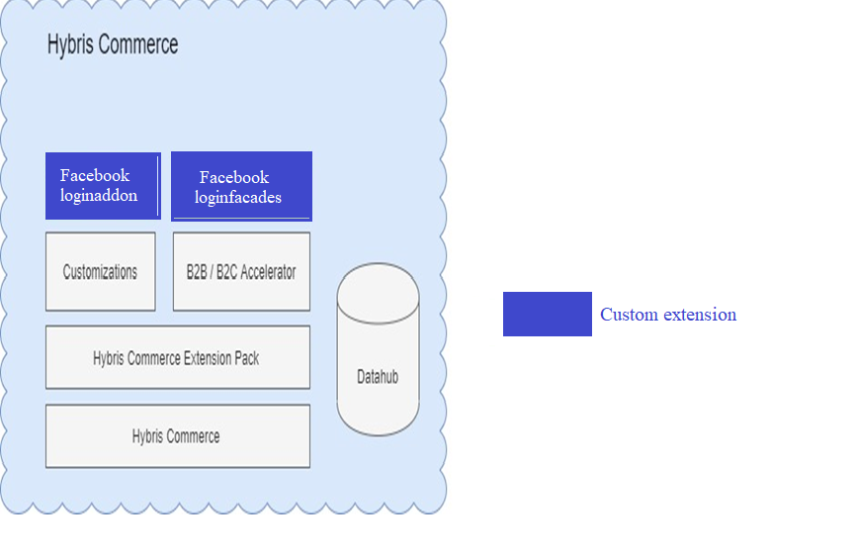

# Design Model:

1. Extension ‘facebookloginaddon’ is mainly communicate with storefront for UI view purpose.
2. Extension ‘facebookloginfacades’ is mainly responsible to communicate with core extensions.
3. Current implementation was done based on Oauth2 framework using openid connect API.

# How to setup:

Step1: Download / clone the extension from git repo

Step2: Put this extension ‘*facebookloginaddon*’ in storefront extension’s exetnsioninfo.xml

Step3: Install the addon.

Step4: Configure the facebook login button in the storefront when your want to place.

Example to enable Facebook login –

Import the tag - <%@ taglib prefix=*"facebook"* tagdir=*"/WEB-INF/tags/addons/facebookloginaddon/shared/"*%>

And then insert

<*facebook*:facebookButton facebookUrl=*"/connect-facebook/login"*/>

Example to enable Facebook register –

Import the tag - <%@ taglib prefix=*"facebook"* tagdir=*"/WEB-INF/tags/addons/facebookloginaddon/shared/"*%>

And then insert

<*facebook*:facebookButton facebookUrl=*"/connect-facebook/register"*/>

Step5: Do ant clean all.

Step6: Start the Hybris server.